CLC Project Assignment – Milestone 1

Dustin Johnson, Isaac Tucker, Isaiah Debenedetto, Kekoa Kubli, Kelly Lamb

Grand Canyon University: CST-339

08/08/2021

**Project Proposal:**

**Epic:** As a user I want a website I can use to post my thoughts and feels so that others may read, interact and post their own thoughts and feelings.

Blog Site

**Domain and products to be managed by the application:**

This application aims to provide a blogging experience where a user will be able to create an account, post content and receive comments and ratings from other users. This application will consist of user accounts, blog posts, blog comments and blog ratings all housed within a SQL database. This data will be utilized in an online view for users to connect to via the internet so that the data can be read and so that users can interact with the data. The team’s current expectation is that the SQL server and application logic and views will be housed on the Microsoft azure platform.

**List of intended features and functionality:**

**US1:** As a user I want to be able to create an account so that I can have my own sense of identity on the application and keep track of my comments and posts.

***Feature:*** Account Creation

***Feature:*** Account Login

**US2:** As a user I want to be able to see blog posts on a central home page ranking from newest to oldest so that I can see other people’s posts.

***Feature:*** Have a listing of blog snapshots for blog selection

***Feature:*** Read past blogs

**US3:** As a user I want to be able to post a blog so that others can read it.

***Feature:*** Post a blog

**US4:** As a user I want to be able to interact with other people’s posts so that I can feel a sense of community on the application.

***Feature:*** Comment on a blog

***Feature:*** Rate Blog

**US5:** As a user I want to be able to edit my post so that I may provide updates and correct mistakes.

***Feature:*** Edit Blog

**US6:** As a user I want to be able to delete a post or a comment so that I can remove out of date information or remove potentially embarrassing content.

***Feature:*** Delete Blog

***Feature:*** Delete Comment

**US7:** As an application owner/Administrator, I need the system to scan blog entries for inappropriate language and sensor it - replacing it with asterisks.

***Feature:*** Profanity filter

**US8:** As a user I want to be able to search blog posts so that I can find content that aligns with my interests.

***Feature:*** Search Blogs

**US9:** As a user I want to be able to sort posts by rating so that I can see what is popular in the community.

***Feature:*** Sort posts by rating

**US10:** As a user I want to be able to find posts by a specific author so that I can follow specific individuals.

***Feature:*** Sort posts by author

**US11:** As a user I want to be able to post a blog privately, for my eyes only, so I can use the site kind of like a personal diary.

***Feature:*** Post privately

**US12:** As a user I want to be able to share my blog entry with people not on the site so I can share my content.

***Feature:*** Share blog / blog posts visible to not-logged in viewers.

**US13:** As an application owner/Administrator, an administrator account must exist to allow editing/deleting user blog entries

***Feature:*** Security **/** System cleanup

**US14:** As an application owner/Administrator, an administrator account must exist to delete/edit user accounts and/or assign different roles to the user.

***Feature:*** Security **/** System cleanup

**US15:** As a user, I would like to see a rating percent on blogs entries (no reaction, thumbs up, thumbs down) accumulated from those that comment (Tied into US4)

***Feature:*** Popularity / Sorting

**US16:** As a user, I would like my account to be secured by an encrypted password

***Feature:*** Security

**Sitemap Draft (initial Sitemap should illustrate all the logical pages of the application and how they will interact with each other):**

Please see the included image below in the design report.

**User interface wireframe concepts or initial designs:**

Please see the included image below in the design report.

**Division of work expectation:**

All team members bring various skills developed through their personal and academic careers to the table. All team members will participate in the sprint planning of each week’s tasks. Sprint items needing completed will be indicated within the agile tool Monday.com each week and team members will assign themselves to the items best suited to their skills. All team members will make sure they take an equal number of weekly items to complete in an effort to ensure overall project completion is on track to meet, if not exceed, classroom expectations. If issues arise during task completion team members will ensure open communication with others to ensure appropriate assistance can be provided and tasks do not go uncompleted.

**Document the risks (technical and functional) that need to be managed moving forward with the project:**

**Resource limitation (website hosting):** Due to limited resources and the lack of funding to expand server space access this application will have limited use of images and other resource intensive data types.

**Time restriction:** the class is only 8 weeks long and team members have full-time jobs and personal lives so time to complete all intended user stories may be limited.

**Personal Lives:** many members of the CLC have let their personal lives take away from their ability to contribute to group discussion/planning.

**CST-339 Programming in Java III**

**Project Status and Design Report**

|  |  |  |
| --- | --- | --- |
| **Topic:** | *CLC Milestone 1* | |
| **Date:** | *08/08/2021* | |
| **Revision:** | *1.0 - Planning Phase* | |
| **Team:** | 1. Dustin Johnson | |
| 2. Isaac Tucker | |
| 3. Isaiah Debenedetto | |
| 4. Kekoa Kubli | |
| 5. Kelly Lamb | |
| **Weekly Team Status Summary:** | |  |  |  |  | | --- | --- | --- | --- | | **User Story** | **Team**  **Member** | **Hours**  **Worked** | **Hours Remaining** | | *Decide Project Proposal* | *All* | *4* | *0* | | *Draft Site Map* | *Kelly Lamb* | *4* | *0* | | *Draft Wireframes* | *Isaac Tucker* | *4* | *0* | | *Consider functionality/domain items* | *All* | *4* | *0* | | *Design paperwork* | *Isaac Tucker* | *4* | *0* | | *SQL DB Design* | *Isaac Tucker* | *4* | *0* | | |
| **GIT URL:** | *The GIT URL that can be used to clone your code and design artifacts.* | |
| **Screencast URL:** | *The URL that can be used to access your screencast demonstration video for the respective assignment.* | |
| **Peer Review:** | **Y** | We acknowledge that our team has reviewed this Report and we agree to the approach we are all taking. |

**Planning Documentation**

**Initial Planning:**

CLC1 - Project Proposal and Planning Phase Monday.com Board

*CLC requirements were separated into trackable tasks and included on the agile tool Monday.com for tracking.*

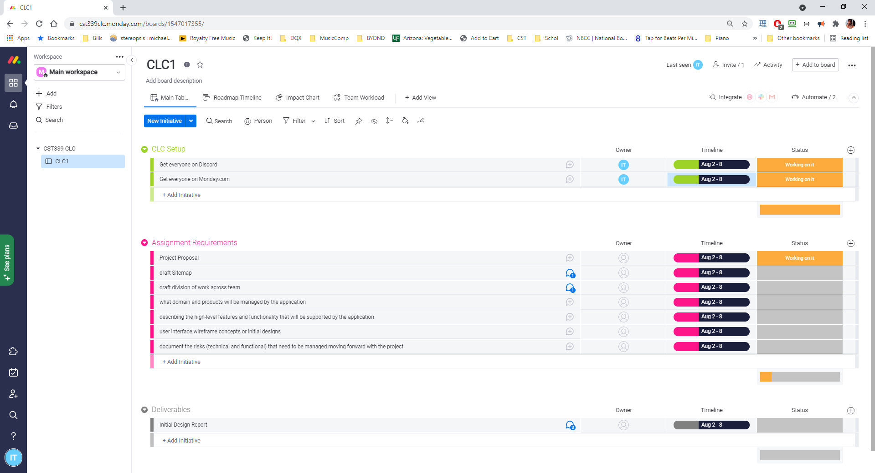

**Retrospective Results:**

|  |
| --- |
| **What Went Well** |
| Team members all signed up for the Discord chat application and Monday.com agile tool for open communication and sprint planning/completion. |
|  |
|  |

|  |  |  |
| --- | --- | --- |
| **What Did Not Go Well** | **Action Plan** | **Due Date** |
| Certain members of the group did not check into the group until day 6 of week 1. | Ensure all members are all signed up for all development related communication/agile applications. | 08/08/2021 |
| Most of week 1’s planning and development was completed by 2 of the 5 members. The other 3 members did not contribute as they were busy with “life events.” | Make sure each member can continually dedicate work toward the group assignment else not receive points for that week’s submission. | Every week. |
|  |  |  |

**Design Documentation**

**Install Instructions:**

*Nothing at this time.*

**General Technical Approach:**

*Design Architecture image.*

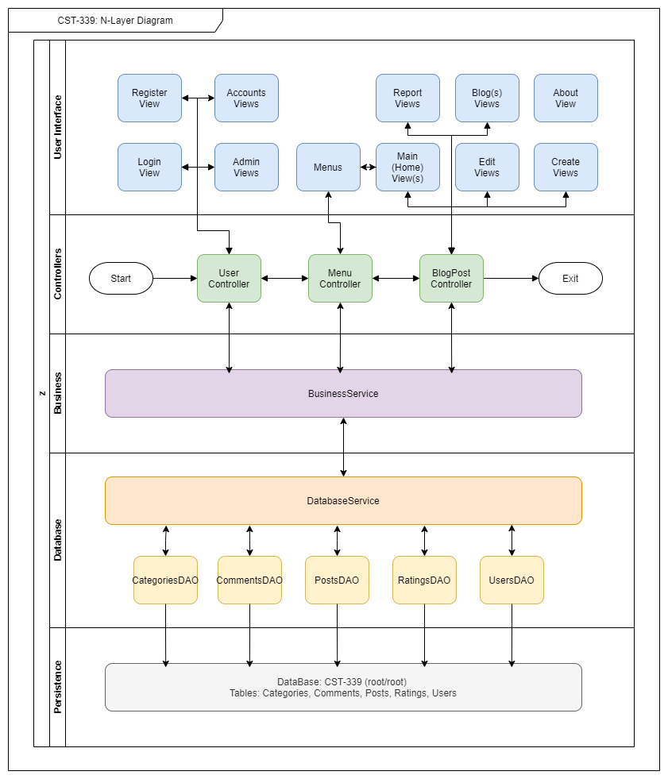

**Key Technical Design Decisions:**

*For the purpose of this class we will be using JAVA with Spring Boot framework. The DataBase is designed using MySQL workbench.*

*The webhosting will be completed on Microsoft Azure.*

**Known Issues:**

*Nothing at this time.*

**Risks:**

***Resource limitation (website hosting):*** *Due to limited resources and the lack of funding to expand server space access this application will have limited use of images and other resource intensive data types.*

***Time restriction:*** *the class is only 8 weeks long and team members have full-time jobs and personal lives so time to complete all intended user stories may be limited.*

***Personal Lives:*** *many members of the CLC have let their personal lives take away from their ability to contribute to group discussion/planning.*

**ER Diagram:**

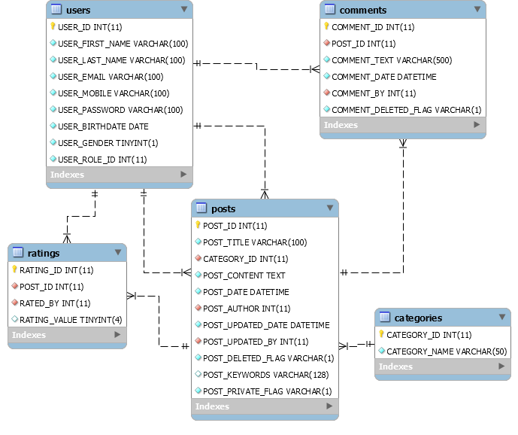

**DDL Scripts:**

*See included file cst339.sql*

**Sitemap Diagram (tentative):**

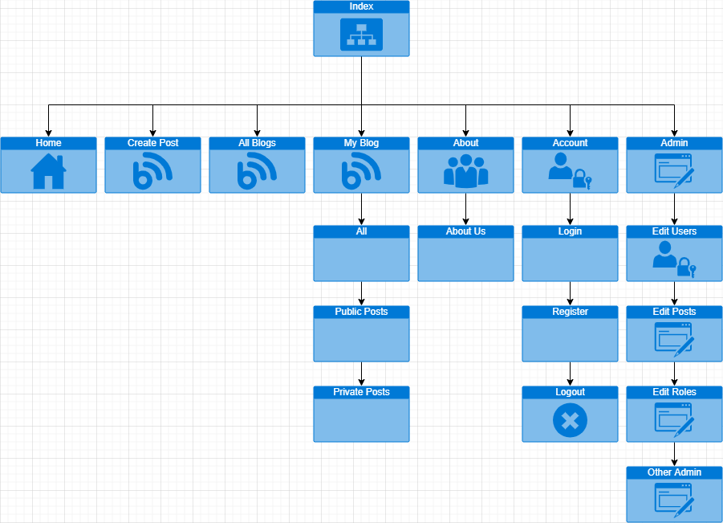

**User Interface Diagrams:**

*Projected index layout*

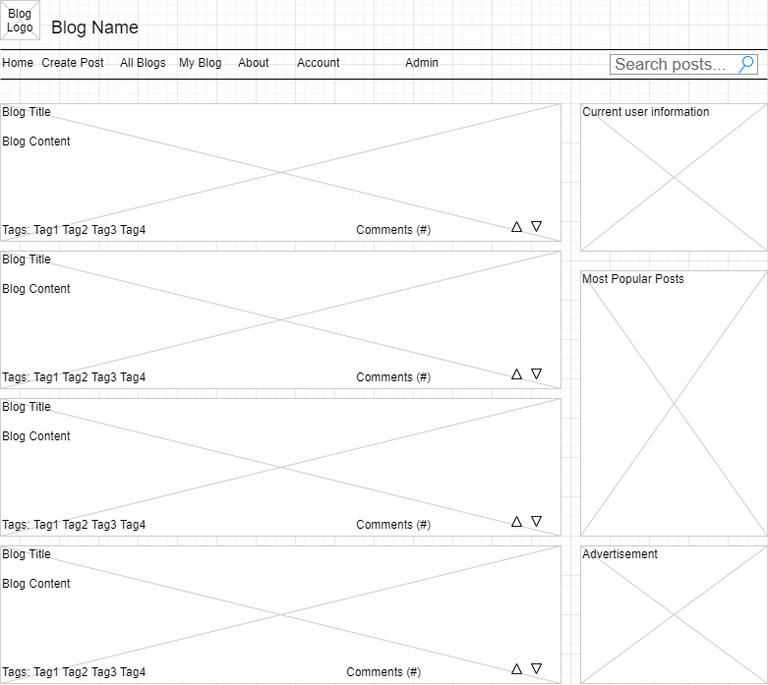

*New user page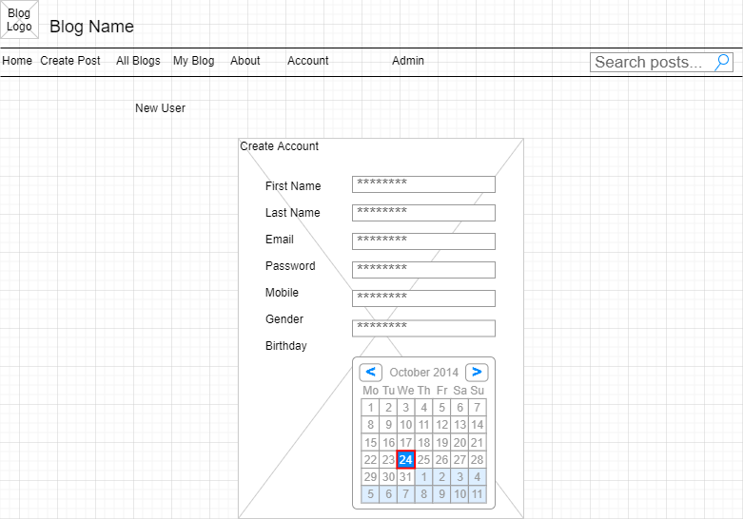*

*Login page*

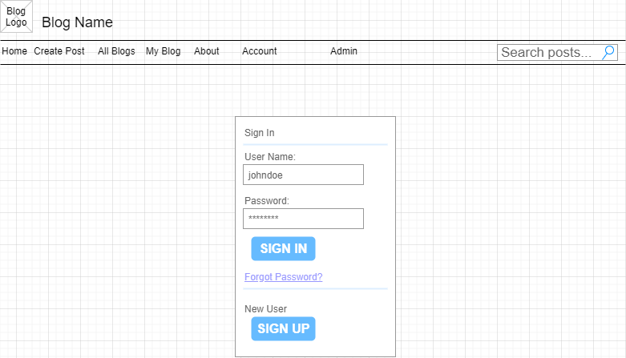

*New Post*

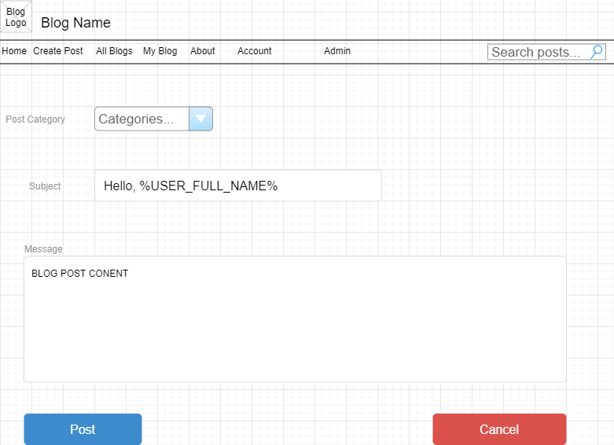

*All posts / My Posts / Search results (ways to list posts in mass)*

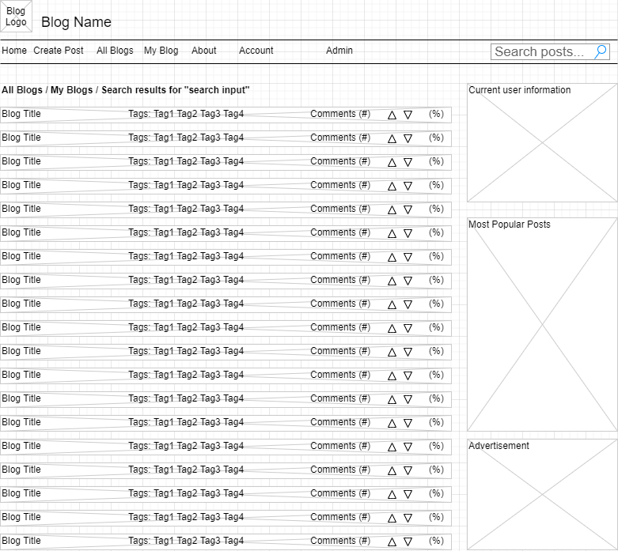

*Single Blog post View*

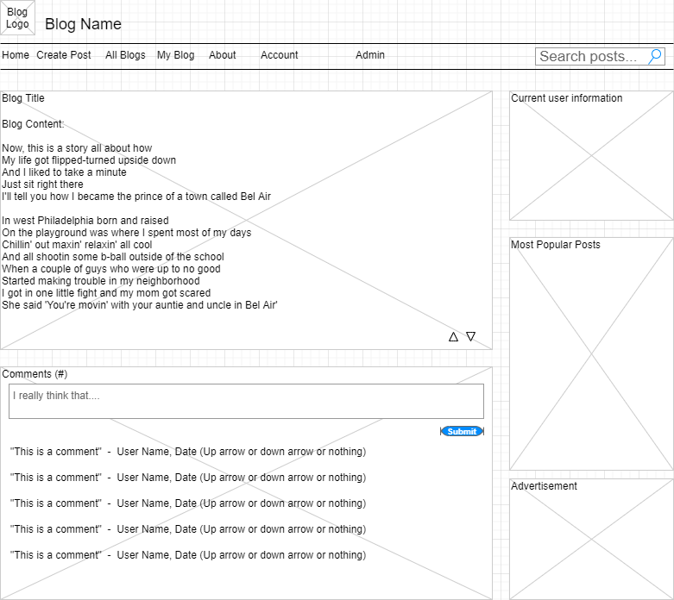

**Class Diagrams (tentative):**

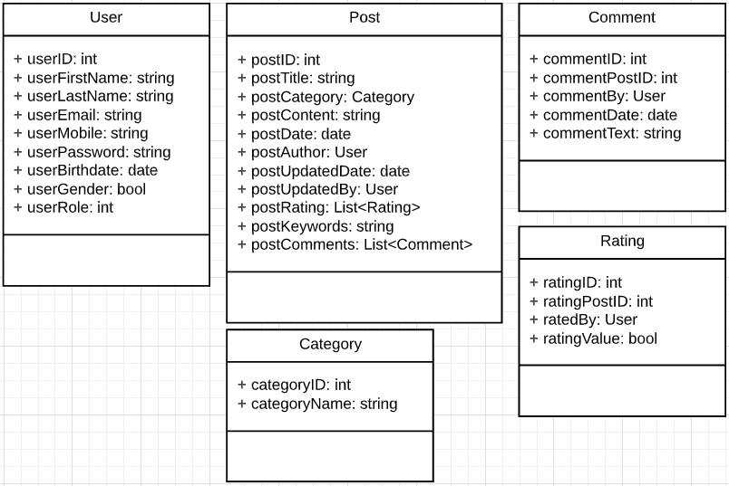

**N-Layer Architecture Diagrams (tentative):**



**Service API Design:**

*Nothing at this time.*

**Security Design:**

*Access to different application features will be determined by role.*

***Expected Roles:***  *Admin - 0; User - 1.*

*Additional security implementations to come.*

*Encrypted Password*

**Other Documentation:**

***List of intended features and functionality:***

***Epic:*** *As a user I want a website I can use to post my thoughts and feels so that others may read, interact and post their own thoughts and feelings.*

*Blog Site*

***US1:*** *As a user I want to be able to create an account so that I can have my own sense of identity on the application and keep track of my comments and posts.*

***Feature:*** *Account Creation*

***Feature:*** *Account Login*

***US2:*** *As a user I want to be able to see blog posts on a central home page ranking from newest to oldest so that I can see other people’s posts.*

***Feature:*** *Have a listing of blog snapshots for blog selection*

***Feature:*** *Read past blogs*

***US3:*** *As a user I want to be able to post a blog so that others can read it.*

***Feature:*** *Post a blog*

***US4:*** *As a user I want to be able to interact with other people’s posts so that I can feel a sense of community on the application.*

***Feature:*** *Comment on a blog*

***Feature:*** *Rate Blog*

***US5:*** *As a user I want to be able to edit my post so that I may provide updates and correct mistakes.*

***Feature:*** *Edit Blog*

***US6:*** *As a user I want to be able to delete a post or a comment so that I can remove out of date information or remove potentially embarrassing content.*

***Feature:*** *Delete Blog*

***Feature:*** *Delete Comment*

***US7:*** *As an application owner/Administrator, I need the system to scan blog entries for inappropriate language and sensor it - replacing it with asterisks.*

***Feature:*** *Profanity filter*

***US8:*** *As a user I want to be able to search blog posts so that I can find content that aligns with my interests.*

***Feature:*** *Search Blogs*

***US9:*** *As a user I want to be able to sort posts by rating so that I can see what is popular in the community.*

***Feature:*** *Sort posts by rating*

***US10:*** *As a user I want to be able to find posts by a specific author so that I can follow specific individuals.*

***Feature:*** *Sort posts by author*

***US11:*** *As a user I want to be able to post a blog privately, for my eyes only, so I can use the site kind of like a personal diary.*

***Feature:*** *Post privately*

***US12:*** *As a user I want to be able to share my blog entry with people not on the site so I can share my content.*

***Feature:*** *Share blog / blog posts visible to not-logged in viewers.*

***US13:*** *As an application owner/Administrator, an administrator account must exist to allow editing/deleting user blog entries*

***Feature:*** *Security* ***/*** *System cleanup*

***US14:*** *As an application owner/Administrator, an administrator account must exist to delete/edit user accounts and/or assign different roles to the user.*

***Feature:*** *Security* ***/*** *System cleanup*

***US15:*** *As a user, I would like to see a rating percent on blogs entries (no reaction, thumbs up, thumbs down) accumulated from those that comment (Tied into US4)*

***Feature:*** *Popularity / Sorting*

***US16:*** *As a user, I would like my account to be secured by an encrypted password*

***Feature:*** *Security*